ve

**CEIR Admin User Manual v 2.1**

* **Central Equipment Identity Register System Admine Portal**

Document Change History

|  |  |  |  |
| --- | --- | --- | --- |
| Version | Change Type | Description | Date |
| Draft |  | Submitted for internal review | February 2020 |

Contents

Document Change History i

Contents ii

Figures iv

1 Overview 1

1.1 Scope 1

1.2 Acronyms & Abbreviations 1

1.3 Conventions 1

2 CEIR Admin Operations 2

2.1 Application Overview 2

2.2 Logging into the Application 2

2.3 Application User Interface 4

2.3.1 Dashboard 6

2.4 Registration Request 10

2.5 Edit Request 12

2.6 Filter Option 14

2.7 Register Device 15

2.8 Filter Register Device 17

2.9 Block/Unblock Device 18

2.10 Filter Block/Unblock Device 21

2.11 Consignment 22

2.12 Filter Consignment 25

2.13 Stock Management 26

2.14 Filter Consignment 29

2.15 Grievance 30

2.16 Filter Grievance 32

2.17 Stolen/Recovery 32

2.18 Filter Stolen/Recovery Management 35

2.19 Manage Type Approval 36

2.20 Filter Manage Type Approval 39

2.21 Pending TAC List 40

2.22 Filter Pending TAC List 41

2.23 Update Visa 42

2.24 Filter Update Visa 44

Figures

Figure 1: Login 3

Figure 2: Home Page 4

Figure 3: Home Page 4

(Change Password): Click on to change the login password. 5

Figure 4: Change Password 5

Figure 6: Home Page 6

Figure 7: Grievance Management 7

Figure 8: Home Page 9

Figure 9: Registration Request – View All 10

Figure 10: Registration Request - Edit 12

Figure 11: System Management – Filter Option 14

Figure 12: Register Device – View All 15

Figure 13: Register Device – Filter Option 18

Figure 14: Block / Unblock Device – View All 19

Figure 15: Block /Unblock Device – Filter Option 22

Figure 16: Consignment – View All 23

Figure 17: Consignment – Filter Option 26

Figure 18: Stock Management – View All 27

Figure 19: Stock Management – Filter Option 29

Figure 20: Grievance – View All 30

Figure 21: Grievance – Filter Option 32

Figure 22: Stolen/Recovery – View All 33

Figure 23: Stolen/Recovery – Filter Option 36

Figure 24: Manage Type Approval – View All 37

Figure 25: Manage Type Approval – Filter Option 40

Figure 26: Pending TAC List – View All 40

Figure 27: Pending TAC List – Filter Option 41

Figure 27: Update Visa – View All 42

Figure 28: Update Visa – Filter Option 44

# Overview

## Scope

The objective of this manual is to help CEIR admin to use the CEIR (Central Equipment Identity Register) application.

## Acronyms & Abbreviations

| **Acronym** | **Full Form** |
| --- | --- |
| CEIR | Central Equipment Identity Register |
| IMEI | International Mobile Equipment Identity |
| PDA | Personal Digital Assistant |
| TAC | Type Allocation Code |
| TRC | Telecommunication Regulator of Cambodia |

## Conventions

| **Information** | **Convention** |
| --- | --- |
| UI elements  (such as names of windows, buttons, and fields) | Bold |
| References  (such as names of files, sections, paths, and  parameters) | *Italics* |
| **\*** | Indicates a mandatory field or column |

# CEIR Admin Operations

## Application Overview

The CEIR (Central Equipment Identity Register) CEIR Admin Portal is used in various work-flow in the CEIR application. The key objective is approving the various kinds of requests.

CEIR Admin perform the following tasks:

* Registration Request
* Register Device
* Block/unblock Device
* Consignment
* Stock Management
* Grievance Management
* Stolen /Recovery
* Manage Type Approval
* Pending TAC List
* Update Visa
* Search

## Logging into the Application

Before login, the CEIR Admin must register in the application.

To register:

As part of configuration, the System Admin would provide the login details to the CEIR admin. It is advised to change the password once System Admin creates the account.

To login:

1. Open the browser and enter the CEIR Admin Portal URL in the address bar. The login screen appears.

Figure 1: Login

On the top right corner of the login screen is the **Language** option. The application supports two languages: **English** and **Khmer**. On selecting a given language, all the field and column labels in the application appear in the selected language. All user inputs are, however, in English.

1. Next, enter the assigned login username and password.

Username is the registration ID that is sent on mail to the CEIR Admin after successful registration in the system.

1. Enter the captcha.
2. Click **LOGIN**.

If the login and password are incorrect or the captcha is not correct, an error message appears, and you are prompted to re-enter the login details.

On entering correct information, the application Home page appears.

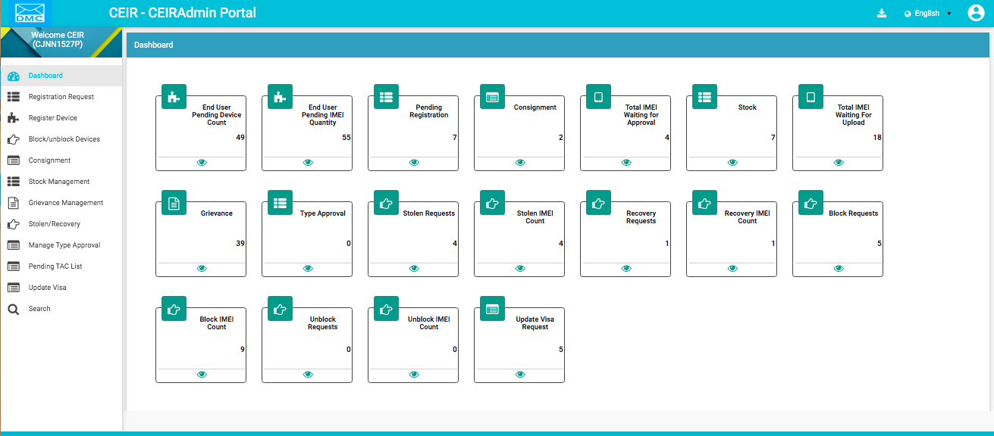

Figure 2: Home Page

If the CEIR Admin forgets the assigned password, then the same need to request from the System admin. The **Forgot Password** link work for external user who register themselves from the DMC portal

## Application User Interface

On logging into the application successfully, the CEIR Admin Portal Home page appears.



Figure 3: Home Page

The Home page has all the feature menus on the left panel.

The top right corner of the screen displays the following menu options:

* **Download**: Click to download this user manual.
* **English**: Select **English** or **Khmer**. All the field and column labels appear in the selected language. User inputs are, however, in English.

* **Home**: Click on it to go to the **DMC Home Portal** page.
* A close up of a logo

  Description automatically generated(**User profile**): Click on it to see the following menu:

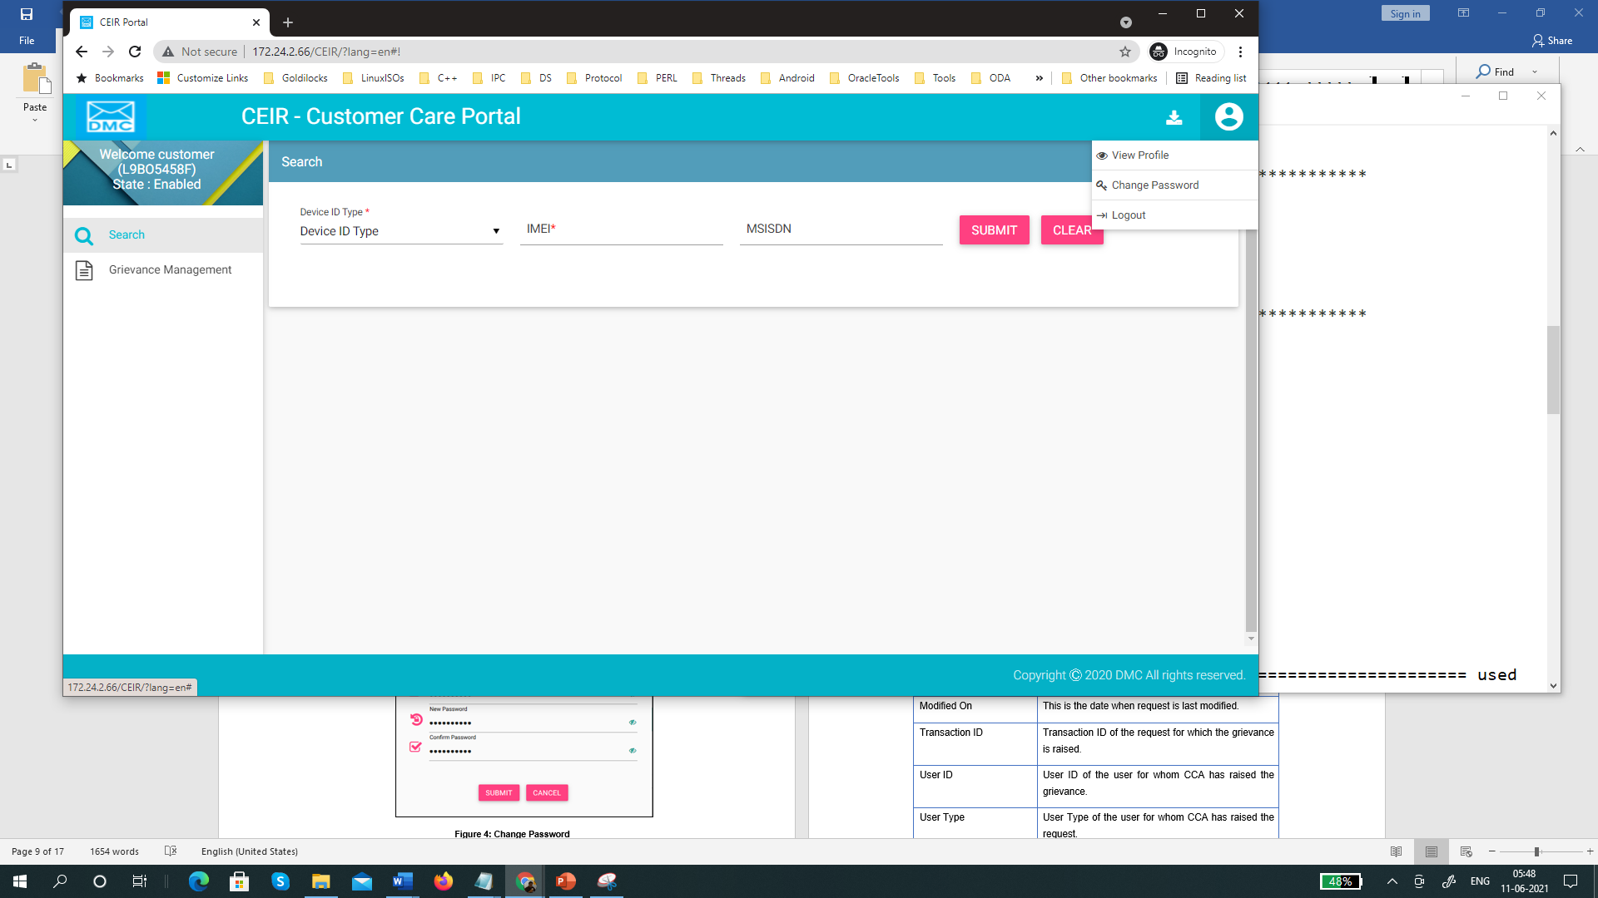

 (Change Password): Click on to change the login password.

Figure 4: Change Password

1. **Old Password**: Enter the existing password. Click  to see the password characters being entered. Click on it again to hide the password characters. This works like a toggle key.
2. **New Password**: Enter a new password.
3. **Confirm Password**: Re-enter the new password to confirm the password.
4. Click **SUBMIT**.

### Dashboard

The Dashboard provides a quick display and access to the following information:

* End User Pending Device Count / Quantity
* Pending Registration
* Consignment / Total IMEI waiting for approval
* Stock / Total IMEI waiting for approval
* Type Approval
* Grievances
* Stolen Requests / Stolen IMEI Count
* Recovery Request / Recovery IMEI Count
* Block Requests / Block IMEI Count
* Unblock Requests / Unblock IMEI Count
* Update Visa Request



Figure 6: Home Page

**As an example, the each box signify as follows**

**Grievances**

The box displays the total number of grievances that are waiting response from CEIR Admin.

Click  **(View)** to access the **Grievance Management** dashboard. Refer to *Grievance Management* for more information.

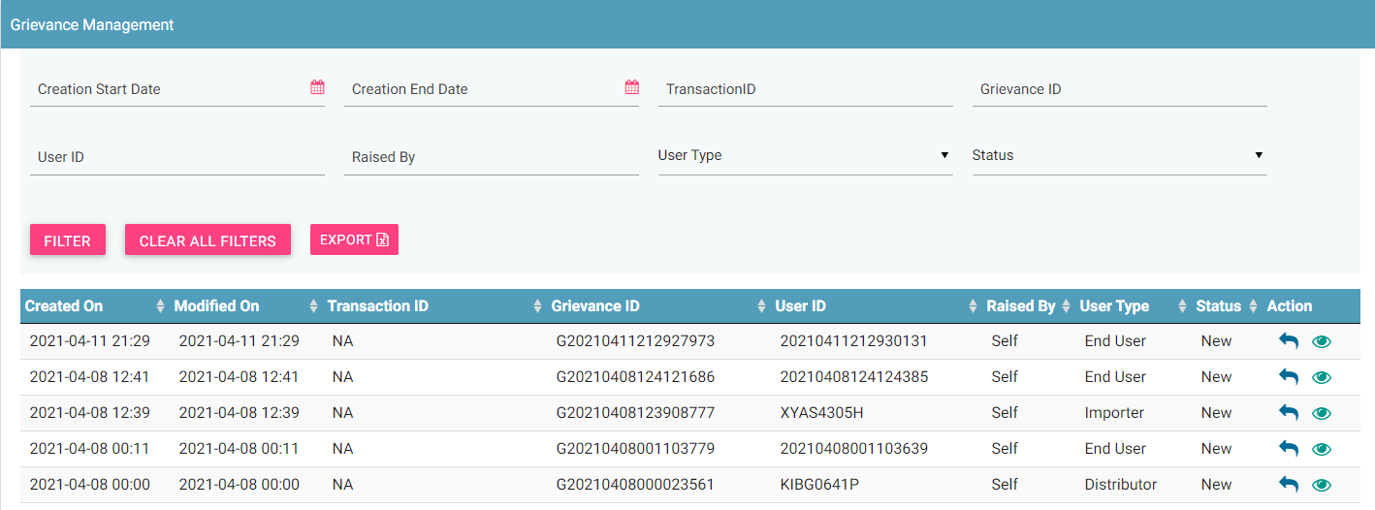

Figure 7: Grievance Management

|  |  |
| --- | --- |
| **Box** | **Description** |
| Type Approved | The box displays the total number of type approval requests that are pending for approval |
| End User Pending Device Count | The box displays the total number of user device requests that are pending for approval raised by end user |
| End User Pending IMEI Quantity | The box displays the total number of user IMEI requests that are pending for approval raised by end user |
| Pending Registration | The box displays the total number of registration requests that are pending for approval raised by user |
| Consignment | The box displays the total number of consignment request that are pending for approval raised by importer |
| Total IMEI waiting for approval | The box displays the total number of IMEI requests that are pending for approval raised by importer |
| Stock | The box displays the total number of stock request that are pending for approval raised by stakeholder like importer, distributor etc |
| Total IMEI waiting for upload | The box displays the total number of stock IMEI request that are pending for approval raised by stakeholder like importer, distributor etc |
| Grievance | The box displays the total number of grievance request that are pending for approval raised by stakeholder like importer, distributor etc |
| Type Approval | The box displays the total number of stock request that are pending for approval raised by stakeholder like importer, TRC etc |
| Stolen Request | The box displays the total number of stolen request that are pending for approval raised by lawful agency |
| Stolen IMEI Count | The box displays the total number of stolen IMEI request that are pending for approval raised by lawful agency |
| Recovery Request | The box displays the total number of recovery request that are pending for approval raised by lawful agency |
| Recovery IMEI Count | The box displays the total number of recovery IMEI request that are pending for approval raised by lawful agency |
| Block Request | The box displays the total number of block request that are pending for approval raised by mobile operators or operation users |
| Block IMEI Count | The box displays the total number of block IMEI request that are pending for approval raised by mobile operators or operation users |
| Un-Block Request | The box displays the total number of un-block request that are pending for approval raised by mobile operators or operation users |
| Un-Block IMEI Count | The box displays the total number of un-block IMEI request that are pending for approval raised by mobile operators or operation users |
| Update Visa Request | The box displays the total number of update visa request that are pending for approval raised by end users |

**Notification Information**

This section displays the most recent notifications. System Admin can configure the number of notifications that are displayed on user dashboard.

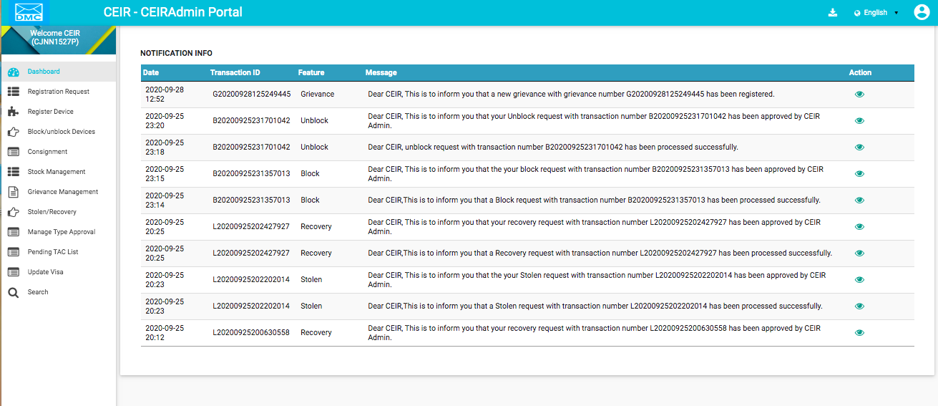

Figure 8: Home Page

Notifications are of two types.

1. Notifications that provide only information. For example, a notification informing the CEIR admin about the account status is an information only notification because it requires no action. The **View** icon () is disabled in such notifications.



1. Notifications that require some action by the CEIR Admin. For example, a notification about the type approval request approval or rejection by the CEIR administrator requires the CEIR admin to take some action such approves the type approval request. The **View** icon () is enabled in such notifications. Click  (**View)** to access the relevant page of the notification.



The notification panel has the following columns:

* **Date**: Date of sending the notification
* **Transaction ID**: Transaction ID of the request for which the notification is sent. If the notification is related to the CEIR admin account, the login username is shown instead of any transaction ID.
* **Feature**: This is the name of the feature for which the notification is sent. For example, if the notification is for a type approval request, the feature name **Type Approval** is shown. The feature name is the one shown in the left panel of the Home page.
* **Message**: This is the message of the notification. An example is shown below.



* **Action**: This shows the **View** icon. It is activated  if the CEIR admin can click on it else it is disabled .

## Registration Request

Using this feature, CEIR admin can approve / reject the registration request.

To approve/reject request:

1. Select **Registration Request** in the left panel.

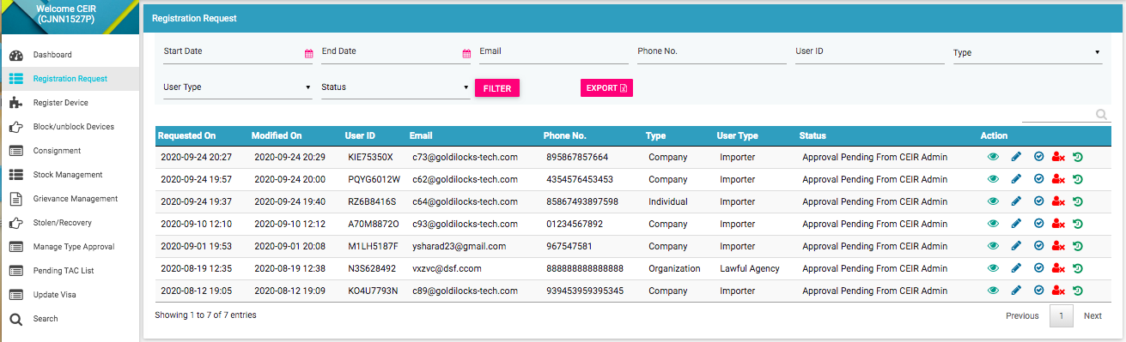

Figure 9: Registration Request – View All

The following columns are seen in the Registration Request Page

| **Column** | **Description** |
| --- | --- |
| Requested On | This is the date of when request is raised by user. |
| Modified On | Date when request is last modified. |
| User ID | ID of the user |
| Email | Email ID of the user |
| Phone no. | Phone number of the user |
| Type | Type of the user like Company, Individual |
| User Type | User Type of user like Importer, Distributor |
| Status | This column shows the various status of the request as follow:   * New: When a request is raised, the status is New. * OTP Verification Pending: The request is received and OTP is sent to user to verify the identity * Approval Pending from CEIR Admin: If the request is successfully verified by the system, the request is shared with the CEIR administrator for review. * Rejected (by CEIR Admin): The CEIR administrator reviews the details and rejects the request if there is a problem. * Approved (by CEIR Admin): When the CEIR administrator approves the request, the status changes to Approved by CEIR Admin. * Disabled: When user disable the account * Enabled: When user enable the account * Deactivate: When user deactivates the account |
| Action | This displays different actions that can be performed on the request.   * View : This is used to view the request details. * Edit A close up of a logo    Description automatically generated: This is used to modify the request details. * Approve : This is used to approve the request. * Reject : This is used to reject the request. * View History : This is used to view the history of this request. |

## Edit Request

CEIR Admins can modify the registration request.

To edit request:

1. Click **Edit (A close up of a logo

   Description automatically generated)** against the request entry to be modified.
2. The **Edit Registration Request** popup page appears.

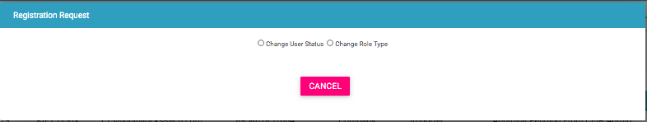

Figure 10: Registration Request - Edit

1. There are 2 options. Refer to below for the screen flow
   1. Change the user Status
   2. Change the Role Type
2. Make the required changes.
3. Click **SUBMIT**.

**To Change User Status:**

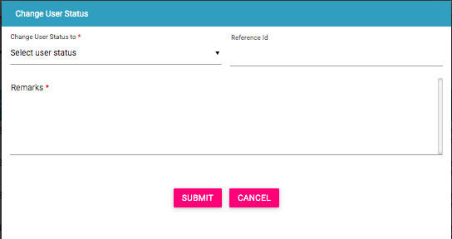

This flow is applicable when user is facing problem during registration and raised a grievance. Reference ID here refers to the grievance ID. CEIR Admin can change the user status to APPROVED using this feature.

**To Change Role Type:**

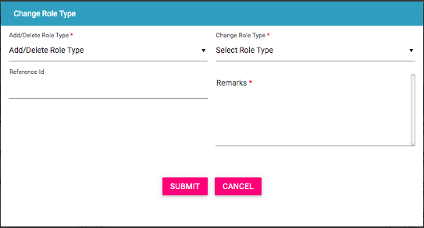

This flow is applicable when importer user wants to change role (add or delete a role type) and raised a grievance. Reference ID here refers to the grievance ID. CEIR Admin can add/delete a role type to an existing user using this feature.

## Filter Option

CEIR Admins can view selective parameters by defining specific values in the listed fields. For example, CEIR Admins can view all the registration request raised during specific start and end dates.

To view specific request:

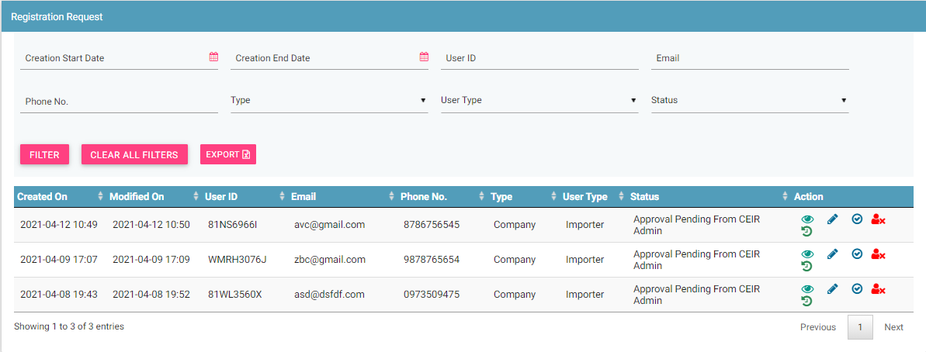

Figure 11: System Management – Filter Option

]]Enter the required value in one or more of the listed fields:

* **Start Date:** Select the start date
* **End Date:** Select the end date
* **Email:** Enter the Email
* **Phone No,:** Enter the Phone number
* **User ID:** Enter the User ID
* **Type**: Select the type of organization
* **User Type:** Select the user type
* **Status:** Select the state of the request

Click **FILTER**.

The parameter that matches the specified values is shown in the page.

The user can clear all filters using the “**Clear All Filters**” button. This will reset all the filter values applied on the page and the data table is refreshed.

To export the filtered date, you can click on export button.

## Register Device

Using this feature, CEIR admin can approve/reject the device request raised by end user.

To approve/reject device:

Select **Register Device** in the left panel.

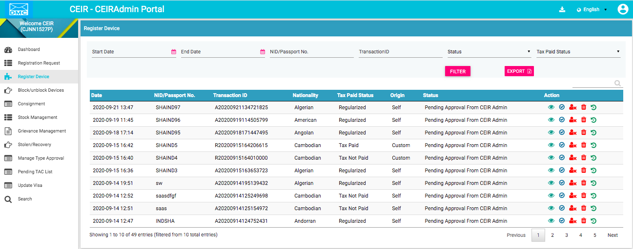

Figure 12: Register Device – View All

The following columns are seen in the Register Device Page

| **Column** | **Description** |
| --- | --- |
| Date | This is the date when request is raised. |
| NID/Passport No. | NID / Passport number of the end user. |
| Transaction ID | Transaction ID generated when end user has raised the request. |
| Nationality | Nationality of the end user. |
| Tax Paid Status | Display the tax status of device |
| Origin | It specifies who has registered the device on end user’s behalf. It can be:   1. end user which is represented as self 2. Immigration department 3. Custom department |
| Status | The request goes through the following status modes:   * New: When a request is raised, the status is New. * Processing: The request is verified internally. * Rejected by System: If the request has an error, an error file is generated. The error file can be downloaded. The error could be in the file format, size, policy violation or request specifications. * Pending Approval from CEIR Admin: If the request is successfully verified by the system, the request is shared with the CEIR administrator for review. * Rejected by CEIR Admin: The CEIR administrator reviews the details and rejects the request if there is a problem. The official can view the error file and fix the errors in the request. * Approved by CEIR Admin: When the CEIR administrator approves the request, the status changes to Approved by CEIR Admin. |
| Action | This displays different actions that can be performed on the message.   * View : This is used to view the request details. * Delete : This is used to delete the request details. * Approve : This is used to approve the request. * Reject : This is used to reject the request. * View History : This is used to view the history of this request. |

## Filter Register Device

CEIR Admins can view selective message by defining specific values in the listed fields. For example, CEIR Admins can view the device registered by specific NID.

To view specific parameter:

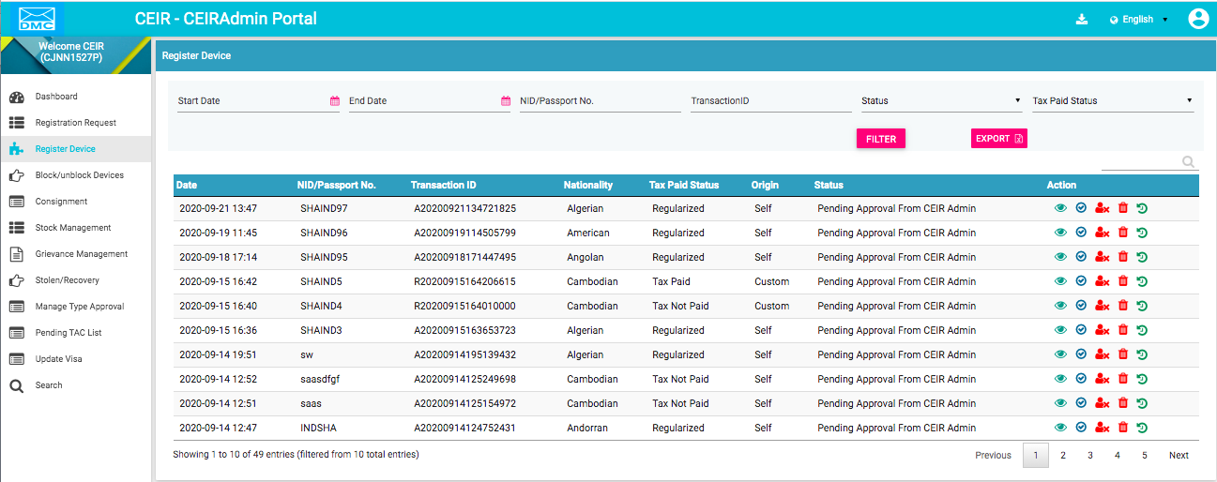

Figure 13: Register Device – Filter Option

1. Enter the required value in one or more of the listed fields:

* **Start Date:** Select the start date
* **End Date:** Select the end date
* **NID / Passport No. :** Enter the NID/Passport of the user
* **Transaction ID:** Enter the Transaction ID
* **Status:** Select the state of request
* **Tax Paid Status:** Select the Tax Paid Status

1. Click **FILTER**.

The parameter that matches the specified values is shown in the dashboard.

The user can clear all filters using the “**Clear All Filters**” button. This will reset all the filter values applied on the page and the data table is refreshed.

To export, click on the export button.

## Block/Unblock Device

CEIR Admins can approve/disapprove the request to block or unblock the device as raised by the user.

To approve/reject the request:

Select **Block/Unblock Device** in the left panel

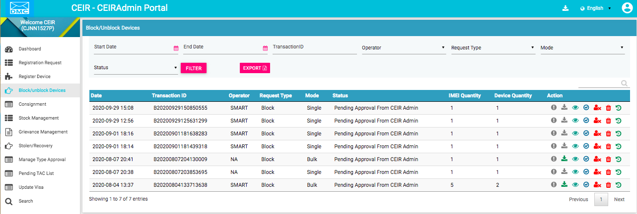.

Figure 14: Block / Unblock Device – View All

The following columns are seen in the Block / Unblock Device Page

| **Column** | **Description** |
| --- | --- |
| Date | This is the date when request is raised |
| Transaction ID | Transaction ID of the request |
| Operator | Name of the operator who has raised the request. In case the request is raised by Operation user, it is set as NA |
| Request Type | The type of request. The possible values are:   * Block * Unblock |
| Mode | Mode of the request. The possible value of this parameter is   * Single * Bulk |
| Status | The request goes through the following status modes:   * New: When a request is raised, the status is New. * Processing: The request is verified internally. * Rejected by System: If the request has an error, an error file is generated. The error file can be downloaded. The error could be in the file format, size, policy violation or request specifications. * Pending Approval from CEIR Admin: If the request is successfully verified by the system, the request is shared with the CEIR administrator for review. * Rejected by CEIR Admin: The CEIR administrator reviews the details and rejects the request if there is a problem. The operator can view the error file and fix the errors in the request. * Approved by CEIR Admin: When the CEIR administrator approves the request, the status changes to Approved by CEIR Admin. * Withdrawn by CEIR Admin: When the CEIR administrator withdraws the request, the status changes to Withdrawn by CEIR Admin. For example, this could be done when the operator has wrongly marked a device as stolen, which has been rightly claimed by another user. * Withdrawn by User: The operator can withdraw the request only when the status is New or Rejected by System. |
| IMEI Quantity | If the request is for a bulk device request, this refers to the number of IMEIs in the **.csv** file else it refers to the IMEIs in the single device being blocked or unblocked. |
| Device Quantity | If the request is for a bulk device request, this refers to the number of devices in the **.csv** file else it refers to the devices in the single device being blocked or unblocked. |
| Action | This displays different actions that can be performed on the request.   * Error : This is enabled when there is an error file generated because of any problem with the file format or policy violation. Click on the icon to download the error file. * Download A circuit board    Description automatically generated: This is used to take a dump of the **.csv** file that is uploaded to the system. This is enabled only for bulk requests. Click on it download the file. * View : This is used to view the request. Click on it view the request details. * Delete : This is used to delete the request. This is allowed only when the request status is New or Rejected by System. Click on it to delete New or Rejected by System. Click on it to delete the request. * Approve : This is used to approve the request. * Reject : This is used to reject the request. * View History : This is used to view the history of this request. |

## Filter Block/Unblock Device

CEIR Admins can view selective information by defining specific values in the listed fields. For example, CEIR Admins can view the specific request during specified date by selecting start/end date.

To view specific request:



Figure 15: Block /Unblock Device – Filter Option

1. Enter the required value in one or more of the listed fields:

* **Start Date:** Select the start date
* **End Date:** Select the end date
* **Operator:** Select the Operator Name
* **Transaction ID:** Enter the Transaction ID
* **Request Type:** Select the Request Type
* **Mode:** Select the Mode
* **Status:** Select the state of request

Click **FILTER**.

The parameter that matches the specified values is shown in the dashboard.

The user can clear all filters using the “**Clear All Filters**” button. This will reset all the filter values applied on the page and the data table is refreshed.

To export, click on the export button

## Consignment

CEIR Admins can approve/disapprove the consignment request for the device as raised by the importer.

To approve/reject the request:

Select **Consignment** in the left panel

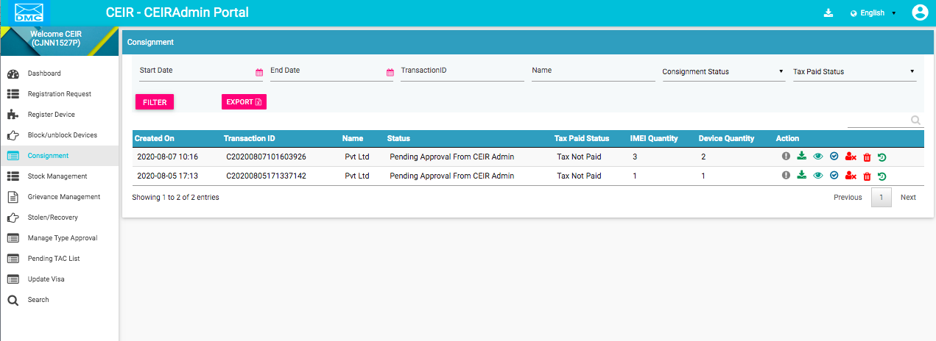

Figure 16: Consignment – View All

The following columns are seen in the Consignment Page

| **Column** | **Description** |
| --- | --- |
| Created On | This is the date when request is created |
| Transaction ID | Transaction ID of the request |
| Name | Name of the importer. In case the importer has registered as individual, this parameter contain the name of importer, but in case the importer is registered as company , then this parameter contain the name of the company |
| Status | The registered consignment goes through different status modes.   * New: When a consignment is registered, its status is **New**. * Processing: The consignment is processed by the application and validated. * Rejected by System: If the consignment does not have valid information, an error file is generated. The importer can view the file and fix the errors in the consignment. * Pending Approval from CEIR Authority: After the consignment is validated by the system internally, the consignment is available for review by the CEIR administrator. * Rejected by CEIR Authority: The CEIR administrator reviews the details and rejects the consignment if there is a problem. The importer can view the file and fix the errors in the consignment. * Pending Clearance from Customs: After the consignment is approved by the CEIR administrator, the consignment is available for clearance by the customs. * Approved: When the customs clear the consignment, the status changes to **Approved**. * Rejected by Customs: When the customs do not clear the consignment, the status changes to **Rejected**. The importer can view the file and fix the errors in the consignment. * Withdrawn by importer: The importer can withdraw the consignment if there is a problem with the consignment. This can be done only when the status is **New** or **Rejected by System**.   Withdrawn by CEIR: The CEIR administrator can withdraw the consignment.. |
| Tax Paid Status | Indicates whether tax has been paid or not. The status changes to **Tax Paid** when the customs clear the consignment.. |
| IMEI Quantity | This is the number of IMEIs in the consignment file |
| Device Quantity | This is the count of the devices in the consignment file. Each device will have the same S/N of the device |
| Action | This displays different actions that can be performed on the request.   * Error : This is enabled when there is an error file generated because of any problem with the file format or policy violation. Click on the icon to download the error file. * Download A circuit board    Description automatically generated: This is used to take a dump of the **.csv** file that is uploaded to the system. This is enabled only for bulk requests. Click on it download the file. * View : This is used to view the request. Click on it view the request details. * Delete : This is used to delete the request. This is allowed only when the request status is New or Rejected by System. Click on it to delete New or Rejected by System. Click on it to delete the request. * Approve : This is used to approve the request. * Reject : This is used to reject the request. * View History : This is used to view the history of this request. |

## Filter Consignment

CEIR Admins can view selective information by defining specific values in the listed fields. For example, CEIR Admins can view the specific request during specified date by selecting start/end date.

To view specific request:



Figure 17: Consignment – Filter Option

Enter the required value in one or more of the listed fields:

* **Start Date:** Select the start date
* **End Date:** Select the end date
* **Transaction ID:** Enter the Transaction ID
* **Name:** Enter the name of importer
* **Consignment Status:** Select the state of request
* **Tax Paid Status:** Select the tax paid status

Click **FILTER**.

The parameter that matches the specified values is shown in the dashboard.

The user can clear all filters using the “**Clear All Filters**” button. This will reset all the filter values applied on the page and the data table is refreshed.

To export, click on the export button.

## Stock Management

CEIR Admins can approve/disapprove the stock request for the device as raised by the importer.

To approve/reject the request:

Select **Stock Management** in the left panel

.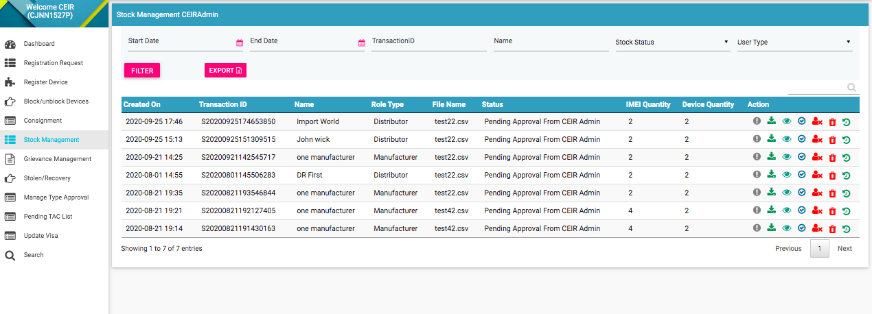

Figure 18: Stock Management – View All

The following columns are seen in the Stock Management Page

| **Column** | **Description** |
| --- | --- |
| Created On | This is the date when request is created |
| Transaction ID | Transaction ID of the request |
| Name | Name of the user. In case the user has registered as individual, this parameter contain the name of user, but in case the user is registered as company, then this parameter contain the name of the company |
| Role Type | Role Type of the user who has raised the request. This field has relevance in case when the user type is importer. For remaining user like manufacturer, the value of this parameter is same as user type |
| Status | The uploaded stock goes through different status modes.   * New: When the stock is uploaded, its status is **New**. * Processing: The stock is processed and validated. The status changes to **Processing**. * Rejected by System If the stock does not have valid information, an error file is generated. The importer can view the file and fix the errors in the consignment. * Approval Pending by CEIR Admin: The uploaded stock is available for review by the CEIR administrator. * Approved by CEIR Admin: The stock is approved by the CEIR administrator. * Rejected by CEIR Admin: The CEIR administrator reviews the details and rejects the stock if there is a problem. * Withdrawn by User: The user withdraws stock if there is any problem.   Withdrawn by CEIR Admin: The CEIR |
| IMEI Quantity | This is the number of IMEIs in the stock file |
| Device Quantity | This is the count of the devices in the stock file. Each device will have the same S/N of the device |
| Action | This displays different actions that can be performed on the request.   * Error : This is enabled when there is an error file generated because of any problem with the file format or policy violation. Click on the icon to download the error file. * Download A circuit board    Description automatically generated: This is used to take a dump of the **.csv** file that is uploaded to the system. This is enabled only for bulk requests. Click on it download the file. * View : This is used to view the request. Click on it view the request details. * Delete : This is used to delete the request. This is allowed only when the request status is New or Rejected by System. Click on it to delete New or Rejected by System. Click on it to delete the request. * Approve : This is used to approve the request. * Reject : This is used to reject the request. * View History : This is used to view the history of this request. |

## Filter Consignment

CEIR Admins can view selective information by defining specific values in the listed fields. For example, CEIR Admins can view the specific request during specified date by selecting start/end date.

To view specific request:



Figure 19: Stock Management – Filter Option

Enter the required value in one or more of the listed fields:

* **Start Date:** Select the start date
* **End Date:** Select the end date
* **Transaction ID:** Enter the Transaction ID
* **Name:** Enter the name of user
* **Stock Status:** Select the state of request
* **User Type:** Select the type of user

Click **FILTER**.

The parameter that matches the specified values is shown in the dashboard.

The user can clear all filters using the “**Clear All Filters**” button. This will reset all the filter values applied on the page and the data table is refreshed.

To export, click on the export button.

## Grievance

CEIR Admins can reply to the grievance request raised by the user.

To reply/close the request:

Select **Grievance** in the left panel

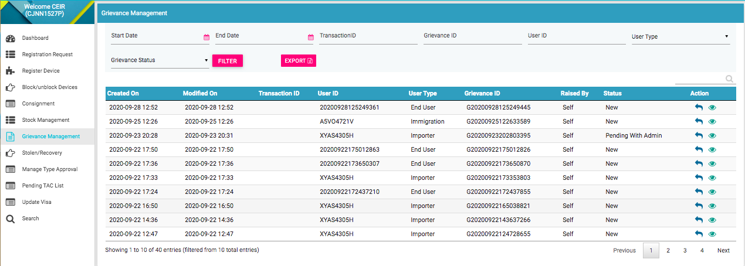

.

Figure 20: Grievance – View All

The following columns are seen in the Grievance Page

| **Column** | **Description** |
| --- | --- |
| Created On | This is the date when request is created |
| Modified On | This is the date when request is last modified. |
| Transaction ID | Transaction ID of the request for which the grievance is raised. |
| User ID | User ID of the user who has raised the grievance. |
| User Type | User Type of the user who has raised the request. |
| Grievance ID | Grievance ID of the grievance |
| Status | The grievance goes through different status modes.   * New: When a grievance is raised. * Pending with CEIR Authority: When a response is awaited from the CEIR administrator. * Pending with User: When a response is awaited from the importer.   Closed: When the CEIR administrator closes the grievance. |
| Raised By | Indicate who has raised the request. The possible value is   * Self – User has raised grievance * Customer Care: Customer care agent has raised the grievance on the behalf of user |
| Action | This displays different actions that can be performed on a grievance.   * Reply : This is used to respond to the grievance. The response is given by the CEIR administrator. The exchange of responses is done until the grievance is closed. There is a option to close the request as well   View A close up of a logo  Description automatically generated: This is used to view the grievance response history. The CEIR admin can see all the responses exchanged for any grievance |

## Filter Grievance

CEIR Admins can view selective information by defining specific values in the listed fields. For example, CEIR Admins can view the specific request during specified date by selecting start/end date.

To view specific request:



Figure 21: Grievance – Filter Option

Enter the required value in one or more of the listed fields:

* **Start Date:** Select the start date
* **End Date:** Select the end date
* **Transaction ID:** Enter the Transaction ID
* **Grievance ID:** Enter the Grievance ID
* **User ID:** Enter the user ID
* **User Type:** Select the type of user
* **Grievance Status:** Select the status of grievance.

Click **FILTER**.

The parameter that matches the specified values is shown in the dashboard.

The user can clear all filters using the “**Clear All Filters**” button. This will reset all the filter values applied on the page and the data table is refreshed.

To export, click on the export button.

## Stolen/Recovery

CEIR Admins can approve/disapprove the stolen/recovery request for the device as raised by the lawful agency.

To approve/reject the request:

Select **Stolen/Recovery** in the left panel

.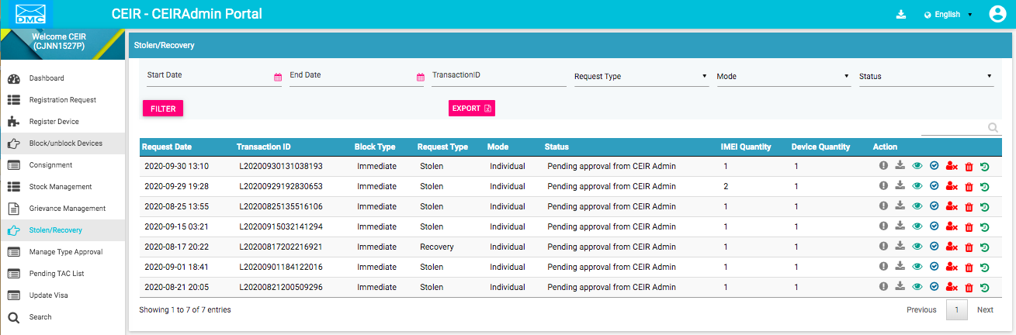

Figure 22: Stolen/Recovery – View All

The following columns are seen in the Stolen/Recovery Page

| **Column** | **Description** |
| --- | --- |
| Request Date | This is the date when request is created |
| Transaction ID | Transaction ID of the request |
| Block Type | The blocking type. The values are   * Immediate: The device(s) is instantly blacklisted. * Default: The device(s) is sent to the blacklist after a given duration. The duration is configurable by the CEIR administrator. * Later: The device(s) is sent to the blacklist at the specified date. |
| Request Type | Request type denotes if the request is for stolen / recovery of devices |
| Mode | Mode denote if the request is single or bulk |
| Status | The request goes through the following status modes:   * New: When a request is raised, the status is New. * Processing: The request is verified internally. * Rejected by System: If the request has an error, an error file is generated. The error file can be downloaded. The error could be in the file format, size, policy violation or request specifications. * Pending Approval from CEIR Admin: If the request is successfully verified by the system, the request is shared with the CEIR administrator for review. * Rejected by CEIR Admin: The CEIR administrator reviews the details and rejects the request if there is a problem. The personnel can view the error file and fix the errors in the request. * Approved by CEIR Admin: When the CEIR administrator approves the request, the status changes to Approved by CEIR Admin. * Withdrawn by CEIR Admin: When the CEIR administrator withdraws the request, the status changes to Withdrawn by CEIR Admin. For example, this could be done when the personnel have wrongly marked a device as stolen, which has been recovered. * Withdrawn by User: The personnel can withdraw the request only when the status is New or Rejected by System |
| IMEI Quantity | This is the number of IMEIs in the request file |
| Device Quantity | This is the count of the devices in the request file. Each device will have the same S/N of the device |
| Action | This displays different actions that can be performed on the request.   * Error : This is enabled when there is an error file generated because of any problem with the file format or policy violation. Click on the icon to download the error file. * Download A circuit board    Description automatically generated: This is used to take a dump of the **.csv** file that is uploaded to the system. This is enabled only for bulk requests. Click on it download the file. * View : This is used to view the request. Click on it view the request details. * Delete : This is used to delete the request. This is allowed only when the request status is New or Rejected by System. Click on it to delete New or Rejected by System. Click on it to delete the request. * Approve : This is used to approve the request. * Reject : This is used to reject the request. * View History : This is used to view the history of this request. |

## Filter Stolen/Recovery Management

CEIR Admins can view selective information by defining specific values in the listed fields. For example, CEIR Admins can view the specific request during specified date by selecting start/end date.

To view specific request:



Figure 23: Stolen/Recovery – Filter Option

Enter the required value in one or more of the listed fields:

* **Start Date:** Select the start date
* **End Date:** Select the end date
* **Transaction ID:** Enter the Transaction ID
* **Request Type:** Select the request type
* **Mode:** Select the mode
* **Status:** Select the status

Click **FILTER**.

The parameter that matches the specified values is shown in the dashboard.

The user can clear all filters using the “**Clear All Filters**” button. This will reset all the filter values applied on the page and the data table is refreshed.

To export, click on the export button.

## Manage Type Approval

CEIR Admins can approve/disapprove the type approval request for the device as raised by the importer/TRC.

To approve/reject the request:

Select **Manage Type Approval** in the left panel

.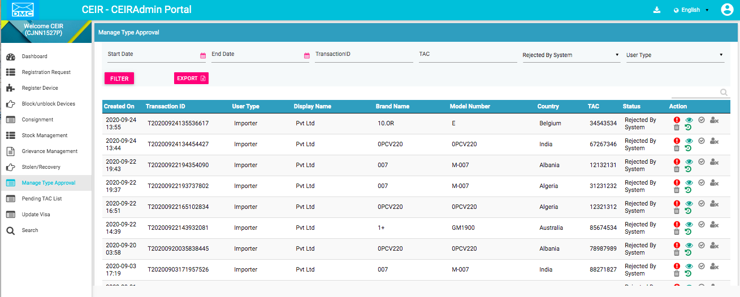

Figure 24: Manage Type Approval – View All

The following columns are seen in the Manage Type Approval Page

| **Column** | **Description** |
| --- | --- |
| Created On | This is the date when request is created |
| Transaction ID | Transaction ID of the request |
| Block Type | The blocking type. The values are   * Immediate: The device(s) is instantly blacklisted. * Default: The device(s) is sent to the blacklist after a given duration. The duration is configurable by the CEIR administrator. * Later: The device(s) is sent to the blacklist at the specified date. |
| User Type | User Type of the user who has raised the request |
| Display name | This contain one of the following values:   * The name of the importer in case importer has registered as individual. * Company name of the importer in case importer has registered as company   In case of TRC, it will be always company name |
| Brand Name | Brand name of the device |
| Model Number | Model number of the device |
| Country | Country where the device is manufactured |
| TAC | TAC number to be approved |
| Status | * New: This is the status assigned to the type approval request. * Processing: The request is processed internally. * Rejected by System: The request is rejected by the system if there is an error in the type approval request. * Approval Pending by CEIR Authority: After the processing is done, the type approval request sent for approval to the CEIR administrator. * Approved by CEIR Admin: The CEIR administrator approves the request. * Rejected by CEIR Admin: The CEIR administrator rejects the request. * Withdrawn by CEIR Admin: The CEIR administrator can withdraw the type approval request. * Withdrawn by User: The importer can withdraw the type approval request. |
| Action | This displays different actions that can be performed on the request.   * Error : This is enabled when there is an error file generated because of any problem with the file format or policy violation. Click on the icon to download the error file. * View : This is used to view the request. Click on it view the request details. * Delete : This is used to delete the request. This is allowed only when the request status is New or Rejected by System. Click on it to delete New or Rejected by System. Click on it to delete the request. * Approve : This is used to approve the request. * Reject : This is used to reject the request. * View History : This is used to view the history of this request. |

## Filter Manage Type Approval

CEIR Admins can view selective information by defining specific values in the listed fields. For example, CEIR Admins can view the specific request during specified date by selecting start/end date.

To view specific request:



Figure 25: Manage Type Approval – Filter Option

Enter the required value in one or more of the listed fields:

* **Start Date:** Select the start date
* **End Date:** Select the end date
* **Transaction ID:** Enter the Transaction ID
* **TAC :** Enter the TAC
* **User Type :** Select the user type
* **Status:** Select the status

Click **FILTER**.

The parameter that matches the specified values is shown in the dashboard.

The user can clear all filters using the “**Clear All Filters**” button. This will reset all the filter values applied on the page and the data table is refreshed.

To export, click on the export button.

## Pending TAC List

CEIR Admins can view the TAC list that is pending for type approval by importer, although importer has raised a consignment for same.

To view the list:

Select **Pending TAC List** in the left panel

.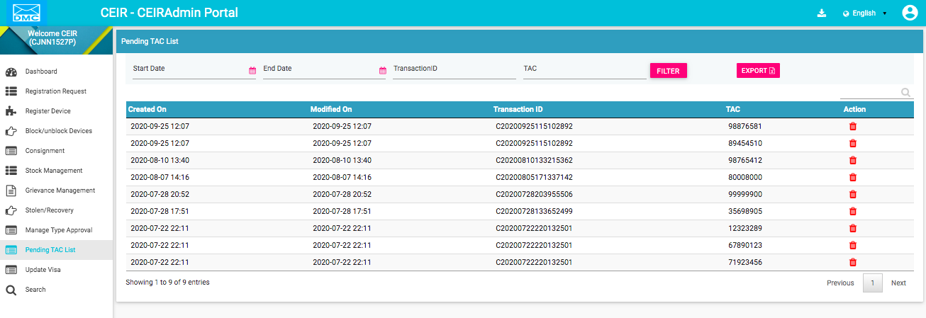

Figure 26: Pending TAC List – View All

The following columns are seen in the Manage Type Approval Page

| **Column** | **Description** |
| --- | --- |
| Created On | This is the date when request is created |
| Modified On | This is the date when request is last modified. |
| Transaction ID | Transaction ID of the request |
| TAC | TAC to be approved |
| Action | This displays different actions that can be performed on the request..   * Delete : This is used to delete the request. |

## Filter Pending TAC List

CEIR Admins can view selective information by defining specific values in the listed fields. For example, CEIR Admins can view the specific request during specified date by selecting start/end date.

To view specific request:



Figure 27: Pending TAC List – Filter Option

Enter the required value in one or more of the listed fields:

* **Start Date:** Select the start date
* **End Date:** Select the end date
* **Transaction ID:** Enter the Transaction ID
* **TAC :** Enter the TAC

Click **FILTER**.

The parameter that matches the specified values is shown in the dashboard.

The user can clear all filters using the “**Clear All Filters**” button. This will reset all the filter values applied on the page and the data table is refreshed.

To export, click on the export button.

.

## Update Visa

CEIR Admins can approve/disapprove the visa update request for the device as raised by the end user.

To approve/reject the request:

Select **Update Visa** in the left panel

.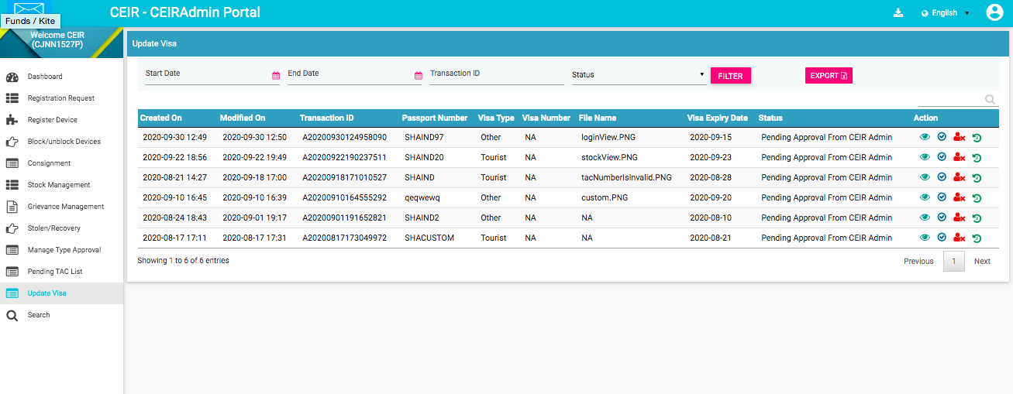

Figure 28: Update Visa – View All

The following columns are seen in the Update Visa Page

| **Column** | **Description** |
| --- | --- |
| Created On | This is the date when request is created |
| Modified On | This is the date when request is last modified |
| Transaction ID | Transaction ID of the request |
| Passport Number | The passport number of the user |
| Visa Type | Type of Visa |
| Visa Number | Visa number. Visa number may not be available as tourist may be travelling from bilateral countries where visa is not required |
| File Name | File containing the Visa image |
| Visa Expiry Date | Date on which visa will expire |
| Status | * New: This is the status assigned to the visa request when it is created. * Processing: The request is processed internally. * Rejected by System: The request is rejected by the system if there is an error in the request. * Approval Pending by CEIR Authority: After the processing is done, the request sent for approval to the CEIR administrator. * Approved by CEIR Admin: The CEIR administrator approves the request. * Rejected by CEIR Admin: The CEIR administrator rejects the request. |
| Action | This displays different actions that can be performed on the request.   * View : This is used to view the request. Click on it view the request details. * Approve : This is used to approve the request. * Reject : This is used to reject the request. * View History : This is used to view the history of this request. |

## Filter Update Visa

CEIR Admins can view selective information by defining specific values in the listed fields. For example, CEIR Admins can view the specific request during specified date by selecting start/end date.

To view specific request:



Figure 29: Update Visa – Filter Option

Enter the required value in one or more of the listed fields:

* **Start Date:** Select the start date
* **End Date:** Select the end date
* **Transaction ID:** Enter the Transaction ID
* **Status:** Select the status

Click **FILTER**.

The parameter that matches the specified values is shown in the dashboard.

The user can clear all filters using the “**Clear All Filters**” button. This will reset all the filter values applied on the page and the data table is refreshed.

To export, click on the export button.

## Search

CEIR Admins can search the IMEI from the CEIR system using this feature

To search the IMEI:

Select **Search** in the left panel

.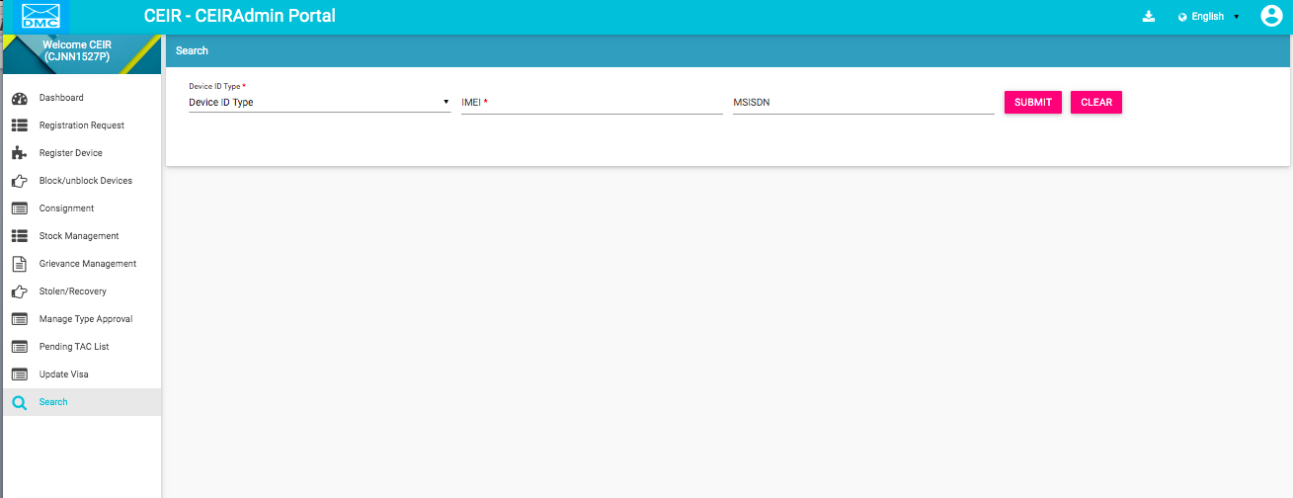

Figure 30: Search – IMEI

The following columns are seen in the Search Page

| **Column** | **Description** |
| --- | --- |
| Device ID Type | Select Device ID Type. |
| IMEI | IMEI that the CEIR admin want to search |
| MSISDN | MSISDN that CEIR admin want to search |

Once the CEIR admin press the submit button, the Device Information page appears

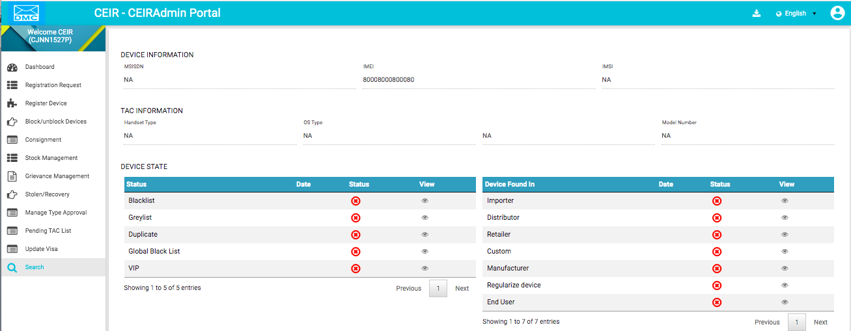

Figure 32: Search – Device Information

The page has the following information categorized into 4 heads

1) Device Information based on the IMEI usage in the network

| **Column** | **Description** |
| --- | --- |
| MSISDN | MSISDN would be displayed if any IMEI is in use with this MSISDN. |
| IMEI | IMEI that the CEIR admin searched |
| IMSI | IMSI would be displayed if any IMEI is in use with this IMSI |

2) TAC information based on the information as available if IMEI has a valid TAC

| **Column** | **Description** |
| --- | --- |
| Handset Type | If the IMEI has a valid TAC, then the Handset Type would be displayed |
| OS Type | If the IMEI has a valid TAC, then the OS Type would be displayed |
| Brand Name | If the IMEI has a valid TAC, then the Brand Name would be displayed |
| Model Number | If the IMEI has a valid TAC, then the Model Number would be displayed |

1. IMEI Status in various conditions

| **Column** | **Description** |
| --- | --- |
| Status | This contain if the IMEI is present in blacklist, greylist, duplicate, global black list, VIP, importer, distributor, retailer, custom, manufacturer, regularize device, end user. End user denote the anonymous stock list uploaded by user. |
| Date | Date on which the entry is created in this list. It will be only be present if the IMEI exist in that list |
| Status | Indicate if the IMEI exist in list. |
| View | If the entry exist in list, the further details about this IMEI can be found for that list |

1. Notifications – In case the user IMEI is not found to be ok, then SMS notification is sent to the user

| **Column** | **Description** |
| --- | --- |
| Date | Date on which the notification is sent |
| Transaction ID | This field is not in use |
| Feature | Feature due to which this notification is sent. |
| Message | If the entry exist in list, the further details about this IMEI can be found for that list |
| Action | This is disabled. |